Video link: https://www.youtube.com/playlist?list=PLTsNSGeIpGnGjaMSYVlidqVWSjKWoBhbr

How to create Databricks
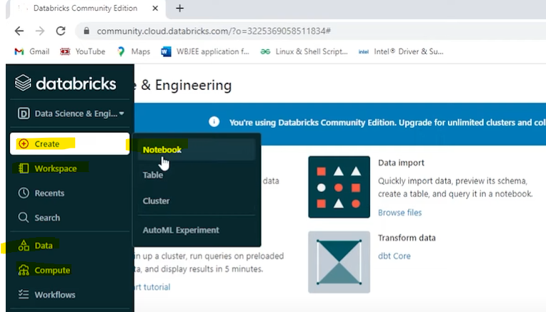
Create > Notebook / cluster.
Data > Crate Table
Compute > Create cluster
Read data in spark
Data file format: CSV, JSON, JDBC/ODBC, Table, parquet
Optional ->
.Option – inferschema, mode, header
.Option – schema (you can manual schema pass)
.Option – load ->path of data location
Spark.read.format(“CSV”)\ # CSV is file format as per use case we need to mention proper file format
.option (“header”,”true”)\
.option (“inferschema”, “true”)\
.option ("mode”,”FAIFAST”)\ # failfast, dropmalformed, permissive
.load (“c:\user\download\data.csv”)
Failfast – will delete corrupted and malformed records.
Dropmalformed – drop the corrupted records.
Permissive (this is a default mode) – whenever we will get corrupted records it will replace null values
++++++++++++++++++++++++++++++++++++++++++++++++++++++++++++++++++++++++++++++++++++++++++++++
Open databrick application > Data > Create Table > Drop file to upload or click to browse>upload csv file>Create Table with UI/Create Table in Notebook
Copy file path like: /FileStore/table/file_Name.csv
Create > Notebook >
Inset Name/ Default Language and Cluster so we need to create cluster, click on create and then create attached and run notebook.
Write below code for read csv file
df=Spark.read.format(“CSV”).option (“header”,”true”).option (“inferschema”, “true”).option ("mode”,”FAIFAST”)\
. load (“c:\user\download\data.csv”)
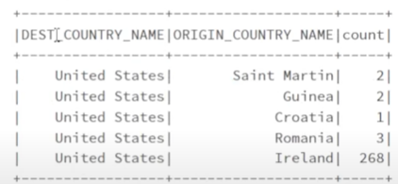
df.show() # it will show csv file data - df.show(10) show only 10 records

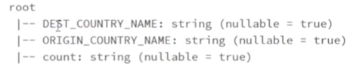
df.printSchema() # it will show schema

++++++++++++++++++++++++++++++++++++++++++++++++++++++++++++++++++++++++++++++++++++++++
Schema:
Question
- How to create schema in pyspark and What are other ways to creating schema?
We can create schema in two way 1. Struct type through and 2. Using DDL.
- Struck type – first we need to import one lib lie – from payspark.sql.types import StructType, StructField,StringType, IntegerType
Based on table the column is a our struck field and Struck type is which define our structure of df. It’s list of struck fields. Struct type is nothing is a collection of struck fields.

Create Manual Schema using Struck Type and Struck filed:
My_Schema = StruckType ([StruckField (“ID”, IntergerType(), True),
StruckField (“Name”, StringType(), True),
StruckField (“Age”, IntergerType(), True)
])
- Create Manual Schema using DDL:
My_Schema = “id integer, name string, age integer”

. schema(My_Schema) # It will read we have created schema.

How to check file is present on not in the particular location?
%fs
Ls /FileStore/tables/
How can skip the first row? For remove header.
.option(“skipRows”,1)
++++++++++++++++++++++++++++++++++++++++++++++++++++++++++++++++++++++++++++++++++++

How to handle corrupted records?
- Have worked with corrupted records?
- When do you say that it corrupted records?
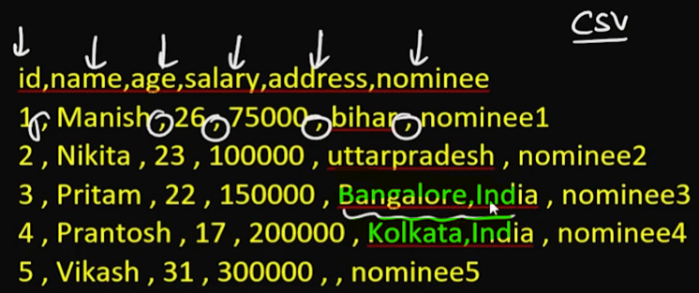
For Json file if the key par missing

- What happens when we encounter with corrupted records in different read mode?
- How can print bad records?
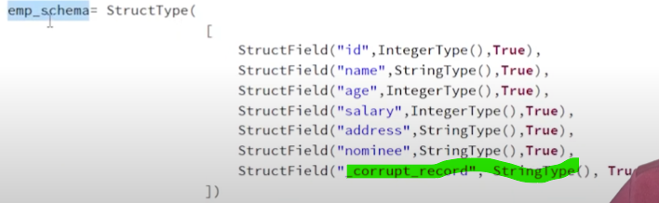
Frist, we need to create Schema

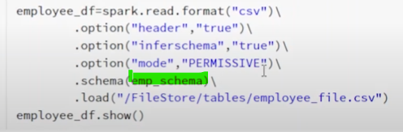

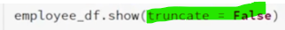

- Where do you store corrupted records and how can we access it later?

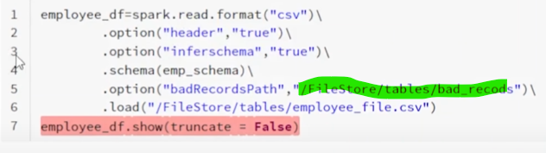

++++++++++++++++++++++++++++++++++++++++++++++++++++++++++++++++++++++++++++++++++++++++++++++
How to read Json file? Java script Object notation
Two type of JSON file and JSON is a Semi structured data file
- Singal line JSON file Ex-
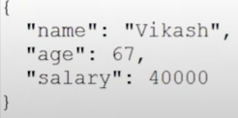
- Multiline JSON file Ex-

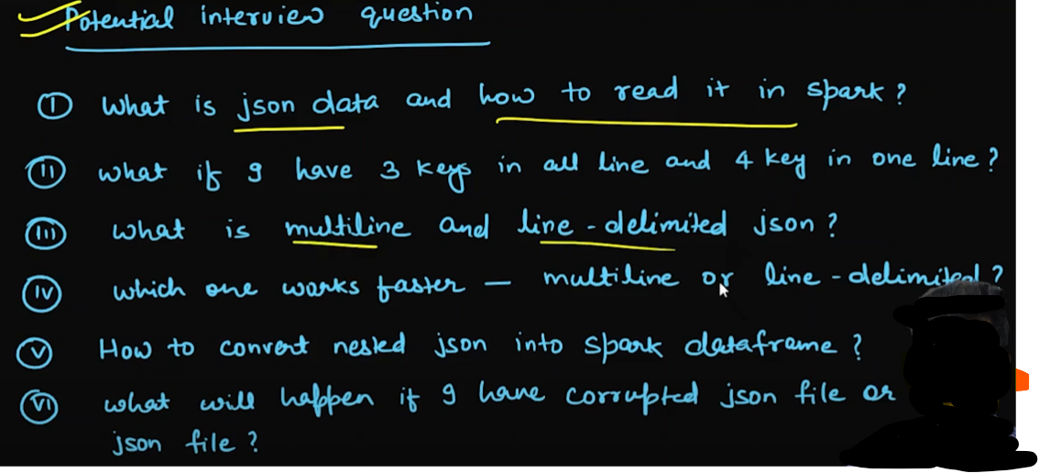
How to read JSON file?
Singal line file
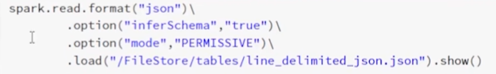
Multiline File
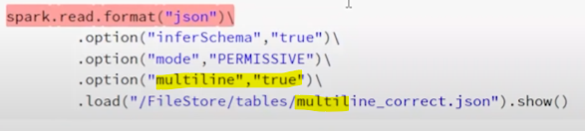
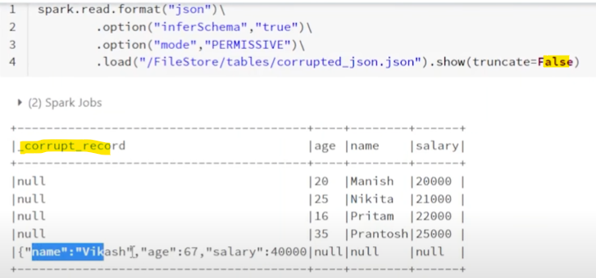

Nested JSON file : this file mostly use in real life
What is Apache Parquet file?
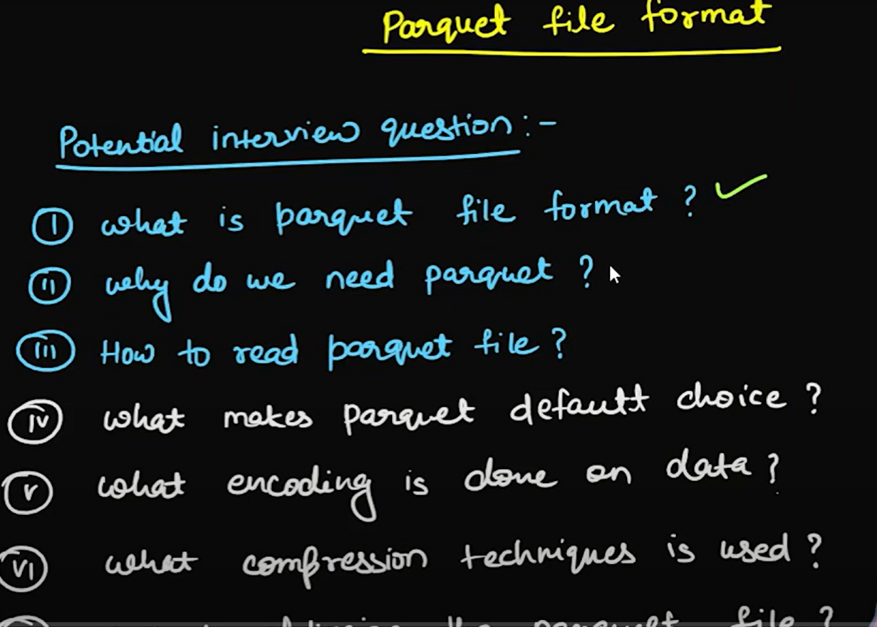

The Parquet file is columnar file format? High performance because it’s read continually, means less shuffling happen
What is row-based file format? Low performance because it’s not read continually, means more shuffling happen
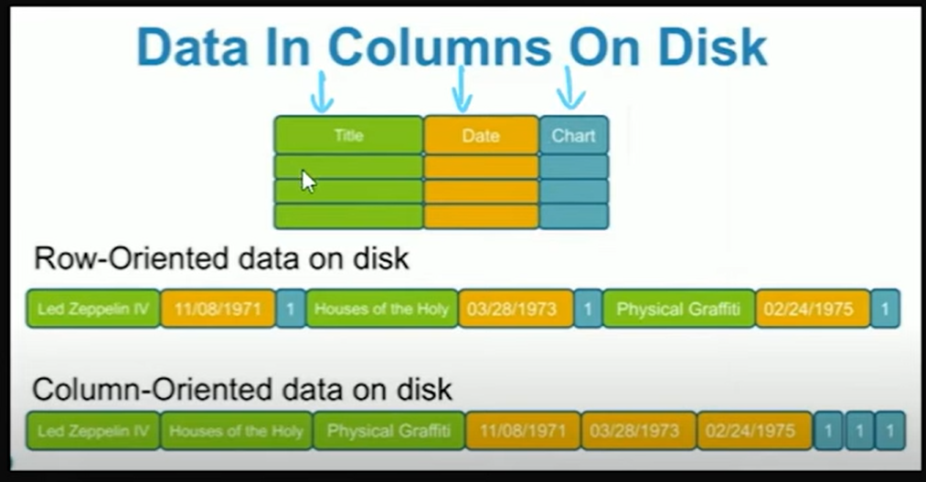

The Parquet is one kind of file format and it’s coming in Bigdata and it’s also structured data
We are doing on Bigdata - Write once and read many time.
How to read parquet file?
df=spark.read.parquet(“/FileStore/table/….”) # File path where we have loaded parquet file
df.show()

How to write data frame to disk in spark?
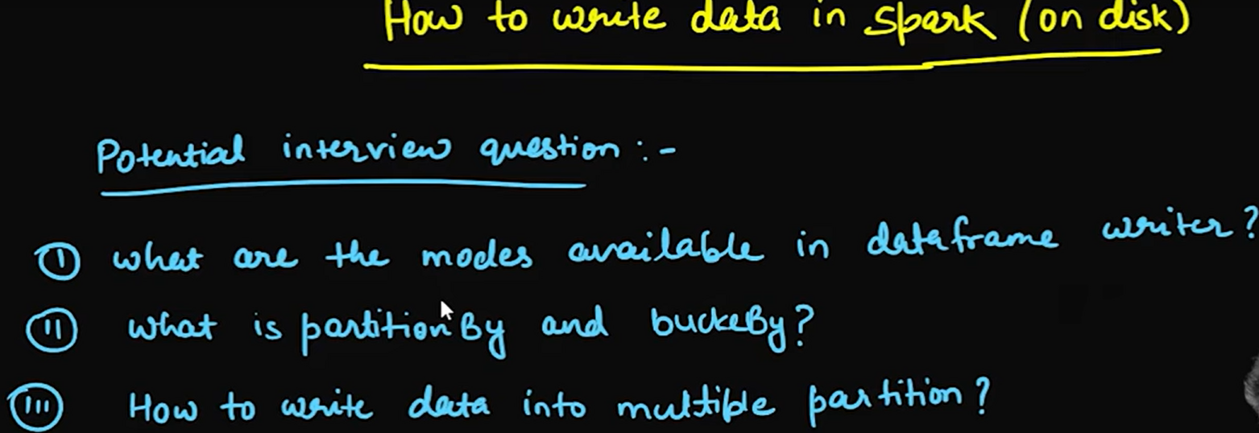
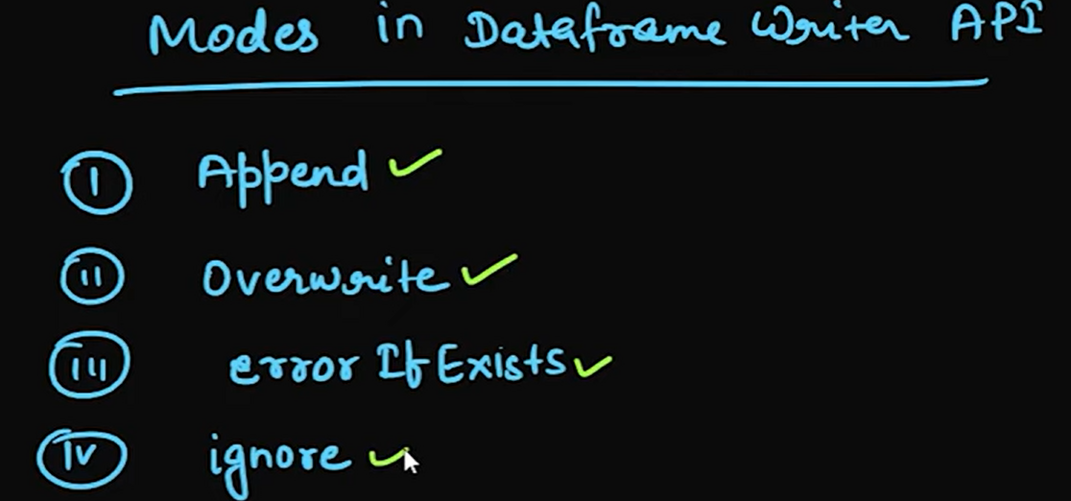
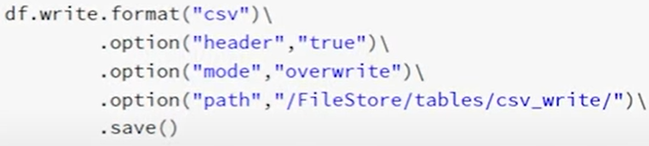
For show data:


Partitioning and Bucketing in Spark:

When we write data then We can partition on particular column like Country column we can partition by country like India, USA, UK and if we have some Rendon data then we can go with bucketing like below Exm.
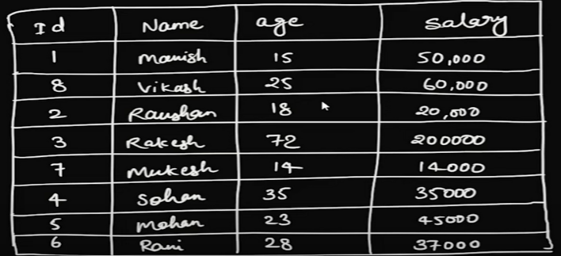

Based on above cash we can create two bucket like ID= 1 to 4 (1st bucket) and ID= 4 to 8 (2nd bucket)
Partition: This below cash we can go with partition using address column
1st partition: India
2nd partition: USA
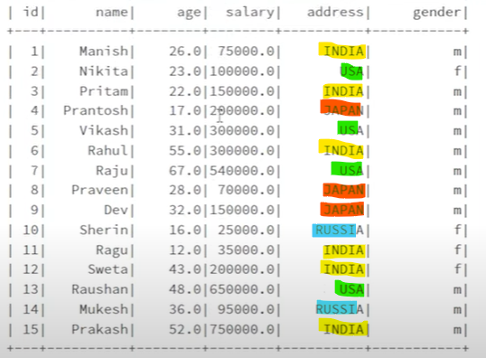
3rd partition: Japan

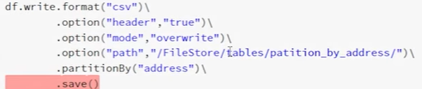

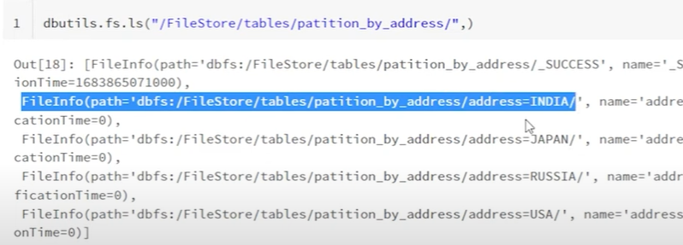

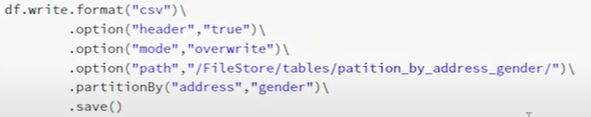
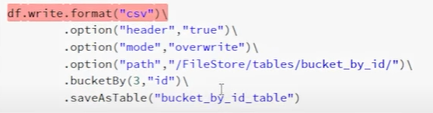
.
++++++++++++++++++++++++++++++++++++++++++++++++++++++++++++++++++++++++++++++++++++++++++++
How to create Data frame in Spark?
Data pipeline
Read -> Transform-> write.
Transform: (1) Dataframe API (2) Spark SQL

